Firewall Configuration, Rule Management & Network Security Hardening

1. Introduction
In today’s digital environment, systems are continuously exposed to unauthorized access, malware, and network-based attacks. A firewall acts as the first line of defense by monitoring and controlling incoming and outgoing network traffic based on predefined security rules.
This project focuses on understanding firewall concepts, configuring firewall rules, allowing and denying ports, testing connectivity, monitoring logs, blocking malicious IP addresses, and documenting the security impact using industry-standard tools like UFW (Uncomplicated Firewall), Windows Firewall, and iptables.

2. Objectives of the Project
The main objectives of this project are:
- To understand core firewall concepts
- To configure firewall rules securely
- To allow and block specific ports
- To test network connectivity after rule implementation
- To observe and analyze firewall logs
- To block malicious or suspicious IP addresses
- To document firewall rules clearly
- To explain the security impact of firewall configurations

3. Tools & Technologies Used

3.1 Primary Tools

UFW (Uncomplicated Firewall)
- Default firewall management tool in Ubuntu/Linux
- Easy-to-use command-line interface
- Built on top of iptables

Windows Defender Firewall
- Built-in firewall in Microsoft Windows
- Provides inbound and outbound traffic control
- GUI and command-line support

3.2 Alternative Tool

iptables
- Low-level firewall utility for Linux
- Highly customizable and powerful
- Used in enterprise and server environments

4. Firewall Concepts (Hint 1)
A firewall is a network security device or software that filters traffic based on rules.

Key Firewall Concepts:
- Inbound Traffic – Data coming into the system
- Outbound Traffic – Data leaving the system
- Allow Rule – Permits traffic
- Deny/Block Rule – Stops traffic
- Port – Logical communication endpoint (e.g., 80, 22)
- Protocol – TCP, UDP, ICMP
- IP Address – Source or destination of traffic

5. Firewall Rule Configuration (Hint 2)
Firewall rules define what traffic is allowed or blocked.

Example (UFW – Linux):

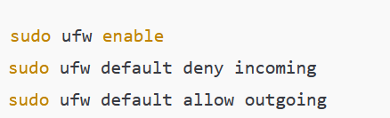

Example (Windows Firewall):
- Open Windows Defender Firewall
- Go to Advanced Settings
- Create Inbound/Outbound Rules
- Specify port, protocol, and action

6. Allowing and Denying Ports (Hint 3)
Ports are commonly targeted by attackers; hence controlling them is critical.

Common Ports:

Port | Service | Action
22 | SSH | Allow (restricted)
80 | HTTP | Allow
443 | HTTPS | Allow
21 | FTP | Block
23 | Telnet | Block

Example Commands (UFW):
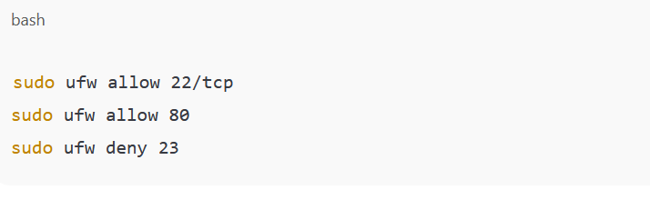

7. Testing Connectivity (Hint 4)
After configuring rules, connectivity must be verified.

Testing Tools:
- ping
- telnet
- netstat
- nmap
Example:
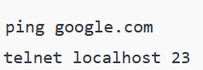

✔ Allowed ports respond
❌ Blocked ports show connection failure

8. Observing Firewall Logs (Hint 5)
Logs help in detecting attacks and troubleshooting.

Enable Logging (UFW):
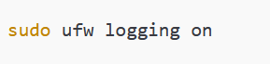

Log Location:
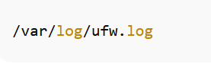
Logs provide:
- Source IP
- Destination Port
- Blocked/Allowed action
- Timestamp

9. Blocking Malicious IP Addresses (Hint 6)
Blocking suspicious IPs reduces attack surface.
Example (UFW):
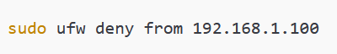
Example (iptables):
This prevents repeated brute-force or scanning attempts.

10. Documentation of Firewall Rules (Hint 7)
Proper documentation ensures clarity and future maintenance.

Sample Firewall Rule Documentation Table:

Rule No | Source IP | Port | Protocol | Action | Purpose
1 | Any | 22 | TCP | Allow | SSH access
2 | Any | 23 | TCP | Deny | Block Telnet
3 | 192.168.1.100 | All | Any | Deny | Malicious IP

11. Impact Analysis (Hint 8)

Security Impact:
- Prevents unauthorized access
- Reduces attack vectors
- Blocks malware communication
- Enhances system hardening

Performance Impact:
- Minimal system overhead
- Efficient traffic filtering

Business Impact:
- Protects sensitive data
- Ensures compliance
- Improves network reliability

12. Conclusion
This project successfully demonstrates firewall implementation and management using UFW, Windows Firewall, and iptables. By configuring rules, controlling ports, monitoring logs, and blocking malicious IPs, the system’s security posture is significantly improved. Firewalls remain a critical component in defending against modern cyber threats.

Screenshots:
